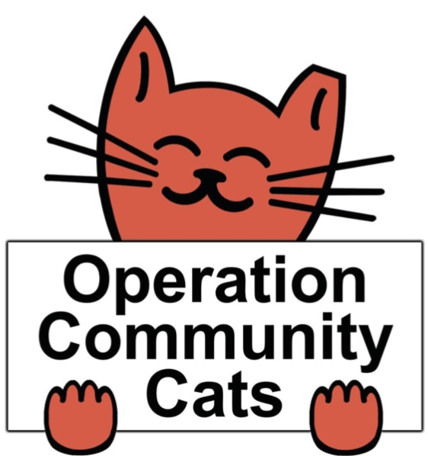

Operation Community Cats

Humane Loan-A-Trap Agreement

And Release of Liability Statement

Operation Community Cats, aka OCC, Loan-A-Trap program offers a Tru Catch humane cat trap for residents free of charge. You must have a spay/neuter appointment scheduled with a licensed veterinary clinic that will spay/ neuter feral cats prior to borrowing a trap. Our traps are only for the use of (TNR) Trap-Neuter-Return of Community Cats. Cats cannot be brought to the shelter or relocated once they are trapped. Your driver’s license and cash, good check, or credit card is required as a refundable security deposit of $100 for the most popular size trap (L30”x W9”,xH11”), the TruCatch LDT30; $125 for one of two fat boy larger traps (L30”xW12”xH14”) and $150 for one of our 2 foldable drop traps (36”x36” x14”). If the trap is not returned after 7 days (or rental agreement time) your credit card will be charged, check cashed for the full price of the trap (method of refundable deposit deposited). Please call 208-477-1550 if you need to make arrangements to extend the time you have the trap(s).

You will have to sign a Trap Loan Agreement agreeing to the below prior to borrowing the trap/s, (please type initials for each item below):

1. _______I understand that trap(s) are only to be used for Trap-Neuter-Return of community (feral, stray, lost, abandon outside) cats/ kittens and am borrowing the trap(s) only for that sole purpose. Trapped cats/kittens may NOT be taken to an animal shelter for euthanasia or surrender, or relocated or released at a location other than where they were trapped, unless it is deemed to be unsafe to release where they were trapped. Traps may not be used to trap any wildlife or hunting purposes; if these animals are trapped accidentally, they must be released unharmed at the location where they were trapped. Traps may not be lent to a third party.

2. _______I understand the trap must be set on level ground so it will remain steady when the cat enters. I must bait the trap with fresh food every time and it is my responsibility to reset the trap and provide the bait for the trap. I understand the trap must be kept covered with a trap cover, towel or sheet while trapping (do not let the cover interfere with the operation of the door) and whenever a community cats is inside the trap. The trap must NEVER be left unattended especially during inclement weather, i.e. extreme cold, extreme heat, storms, etc.

3. ________I understand that any animal, including community cats, can act unpredictably when trapped. I agree to not open any trap, stick hands or fingers inside the trap, or handle any trapped animal unless specifically instructed. I release Operation Community Cats and its staff and volunteers from any liability for any injuries or damages that may occur from trapping, confining, transporting, or releasing these cats.

4. ________ I understand that no cat/ kitten will be kept in a trap more than 24 hours before or after being spay/ neutered.

5. ________ I understand that when the feral/community cat(s) is/are caught, I need to cover the trap with a towel or blanket to relieve the animal’s stress immediately. I must take the cat in the covered trap to a vet for spay/neuter within 24 hours. I will trap on a schedule prearranged with the vet clinic doing the spay/neuter surgery.

6. ________ OCC makes no representations and/or warranties as to the trap(s) and I take the trap(s) “as is.”

7. _______I understand that it is my responsibility to return the trap(s) in the same condition they were lent, and clean—newspapers removed, traps cleaned and disinfected**—so the trap can be stored or loaned out right after returned. In the event that I will need the trap(s) past the above-mentioned return date, I will call and make arrangements; otherwise, OCC will assume that I am not returning the trap(s) and will deposit my check, cash or charge my credit card. There will be a $5 trap cleaning fee for each trap if the trap is returned dirty. A $5 charge will also be charged for each trap returned without the carabiner, which is necessary to lock the rear door of the trap. Deposits will not be refunded in the case of lost, damaged or stolen traps.

8. ________ I hereby warrant that I have the right to enter into this Agreement. I represent that I am over eighteen (18) years of age.

9. ________ I hereby warrant that I have read this Agreement carefully prior to its execution and fully understand its contents. I am aware that this is a waiver and release of liability and an enforceable legal document between myself, and Operation Community Cats and I sign of my own free will. This Agreement shall be binding upon me and my heirs, executors, successors, assigns or other legal representatives.

10.________I hereby relieve Operation Community Cats, its volunteers, Board of Directors, veterinaries, clinic, vet techs and all procedures involved with SpayNeuter, Trapping, Transport, Release, Recovering of all personal and monetary liability.

BORROWERS NAME:___________________________________________________________

ADDRESS: ____________________________________________________________________

CITY, STATE, ZIP: _______________________________________________________________

EMAIL:_______________________________________________________________________

CELL #:_______________________________________________________________________’

ALTERNATIVE #:________________________________________________________________

EMERGENCY NAME & PHONE #:__________________________________________________

DATE OF SPAY/ NEUTER APPOINTMENT:________________ HOW MANY FERALS:________

NAME OF VET CLINIC & CITY: ____________________________________________________

PRINT NAME: __________________________________________________________________

I AGREE THAT MY TYPED NAME BELOW REPRESENTS MY SIGNATURE

SIGNATURE: __________________________________________________________________

*Operation Community Cats reserves the right to refuse trap rental to anyone in the event of noncompliance with the terms of this agreement or intentional or knowing misuse, loss or damage of any property. Abandoning animals is animal cruelty. Any person abusing or neglecting a captured animal will be prosecuted.

*Operation Community Cats offers humane traps for a 7-day refundable rental period or the dates reflected on this agreement, a copy will be emailed to you when completed and traps picked up. The rental fee is free for the period reflex on this form below with a $100-$150 refundable deposit/per trap or credit card on file. The deposit will be returned after the trap has been returned. There will be a $5 trap cleaning fee if the trap is returned dirty. Deposits will not be refunded in the case of lost, damaged or stolen traps.

\*\***Clean**, **clean**, and **clean** again.

Thoroughly sanitize each trap and trap divider before and after all trapping. Scrub every part of the trap and trap dividers, spray a solution of one-part bleach to 10 parts water on all surfaces, and then rinse it off after 10 minutes.

*Learn the truth about Feral Cats and how trap-neuter-return works as a humane solution to reduce the population of feral (community) cats. Our friends at [Allie Cat Allies](http://www.alleycat.org/) have all of the resources needed to help you TNR outdoor cats. Also check [boiseid.net](http://boiseid.net) for instructions and resources for low cost spay neuter resources in the area.

| DATE | TRAP # | RENTAL AMOUNT | DATE TO BE RETURNED |
| --- | --- | --- | --- |
|  |  |  |  |
|  |  |  |  |
|  |  |  |  |
|  |  |  |  |
|  |  |  |  |
|  |  |  |  |
|  |  |  |  |
|  |  |  |  |
|  |  |  |  |
|  |  |  |  |
|  |  |  |  |
|  |  |  |  |
|  |  |  |  |
|  |  |  |  |
|  |  |  |  |
|  |  |  |  |
|  |  |  |  |
|  |  |  |  |
|  |  |  |  |
|  |  |  |  |
|  |  |  |  |
|  |  |  |  |
| **TOTAL** |  |  |  |

ONLY AN OPERATION COMMUNITY CATS APPROVED VOLUNTEER TO FILL